Carmenita Higginbotham

PO Box 400130

University of Virginia

Charlottesville, VA 22904-4130

[ch6sv@cms.mail.virginia.edu](mailto:ch6sv@cms.mail.virginia.edu)

**American Impressionism**

American Impressionism was an art movement that flourished in the United States in the late nineteenth and early twentieth centuries. It explored the aesthetic effects of light and atmosphere as it sought to create a modern American art that incorporated contemporary aesthetic techniques drawn from European precedents. Stylistically, American Impressionism was inspired by the rapid brushwork and high key palette of French Impressionist painting, particularly the work of Claude Monet and Pierre-Auguste Renoir. Through plein-air or out of doors landscapes and scenes of domestic interiors, American impressionist painters including William Merritt Chase, Childe Hassam, Julian Alden Weir, Theodore Robinson, Thomas Dewing, and John Twachtman balanced articulating the ethereal quality of the sensory experience with a commitment to realist representation. Impressionism in the United States developed from the training of American artists in European countries after the American Civil War (1861-1865), and the exhibition of French Impressionist painting in cities such as New York in the 1880s and 1890s. Its artists sought a contemporary visual style that conveyed experiential shifts triggered by social, cultural and technological diversification and growth at the turn of the century.

The American Impressionists drew from the example of Monet, Renoir, Edgar Degas, and Mary Cassatt to explore the ephemeral nature of perception in modern life. American Impressionist artists adopted a quick or flickering painting technique and bright pigments to articulate how one perceived an object at a specific moment. They also looked to the design principles of nineteenth-century Japanese print work for their unique use of perspective and compositional arrangement. The decorative patterns in Chase’s *In the Studio* (1882); the delicate stain of colours in Dewing’s *Venetian Brocade* (1904); and the tonal harmonies in Twachtman’s *Winter Harmony* (1890-1900) highlight atmospheric qualities and surface effects as much as the subjects of their paintings. Integrating figure and setting, American Impressionist artists celebrated a harmony of art and life.

At the end of the nineteenth century, American Impressionism was popular among wealthy art patrons and private collectors who considered its genteel subject matter and European references to be appropriate expressions of an affluent class status. Paintings that featured light-infused landscapes of the rural countryside, panoramic urban scenes, and elegant interior spaces offered a romanticised vision of modernity in the 1890s and 1900s. Public interest in American Impressionism waned by the late 1910s, but its impact was broadly felt in art colonies and art schools throughout the United States. Many of the movement’s participants, including Chase and Weir, became instructors at the Pennsylvania Academy of Fine Arts in Philadelphia, one of the country’s premiere art institutions of the time.

**References and further reading**

Burns, S. (1996) *Inventing the Modern Artist: Art and Culture in Gilded Age America*, New Haven: Yale University Press.

Gerdts, W. (2001) *American Impressionism*, 2nd ed., New York: Abbeville Press.

Weinberg, H. Barbara, Doreen Bolger, and David Park Curry. (1994) *American Impressionism and Realism: The Painting of Modern Life, 1885-1915*,New York: Harry N. Abrams and the Metropolitan Museum of Art.

http://www.metmuseum.org/toah/hd/aimp/hd_aimp.htm

http://americanart.si.edu/treasures/1ai/index.html

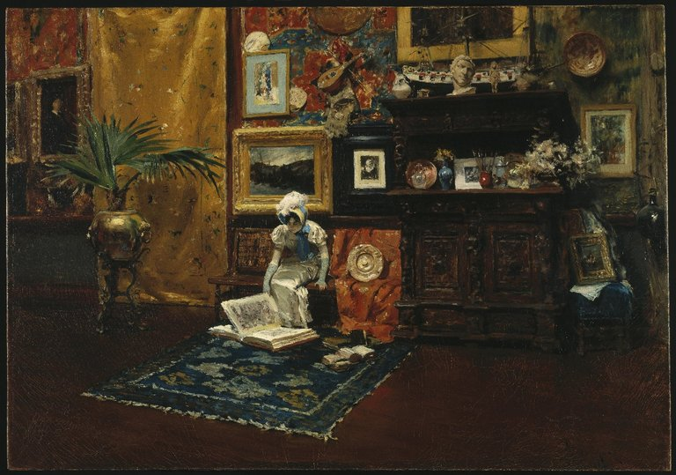

William Merritt Chase, *In the Studio*, 1882. Oil on canvas. 28 1/16 x 40 1/8 in. (71.2 x 101.9 cm)

<http://www.brooklynmuseum.org/opencollection/objects/28/Studio_Interior/image/14587/image>